WEB DEVELOPMENT PHASE 3 FINAL PROJECT DOCUMENTATION

28-10-2022

pHANTOMS

DAVID NWACHUKWU 36232416 & VUSIMUZI SOLANI 34414290

2022

Table of Contents

PHASE ONE 4

Introduction 5

Abstract. 5

Problem 5

Proposed solution 5

Proposed system 5

Objectives of the proposed system 6

Systems request 7

SWOT Analysis 8

Feasibility analysis 9

Operational Feasibility 9

Economic Feasibility 9

Technical Feasibility 9

Schedule Feasibility 9

Evaluating Feasibility 10

Preliminary Investigation 11

Preliminary Investigation Overview 11

Understand the problem or opportunity 11

Defining the project scope 11

Fact-finding 11

Questionnaires 12

Analyse project usability, cost, benefits, and schedule data 14

Project Plan 15

As-Is Analysis 17

As-Is analysis diagram 18

To-Be Analysis 18

Requirements Determinations 19

Functional requirement 19

Use cases 21

Use case diagram 21

Data and Process Models 25

Context diagram 25

Diagram 0 26

Meetings 27

Meeting 1 27

Attendees 27

Agenda 27

Analysing the business case 27

Evaluating the systems request 27

Notes 27

Action Items 27

Next Meeting Agenda Items 27

Meeting 2 28

Attendees 28

Agenda 28

Project planning 28

Developing a project plan 28

Notes 28

Action Items 28

Next Meeting Agenda Items 28

Meeting 3 29

Attendees 29

Agenda 29

Requirements determinations and documentation 29

Developing use cases process models 29

Notes 29

Action Items 29

Next Meeting Agenda Items 29

PHASE TWO 30

2.1. Design Strategy. 31

2.2. Design Architecture. 32

2.1.1. Three-tier Architecture 32

2.1.1 The Client 33

2.1.2 The Application Logic 33

2.1.3 Database Server 33

2.2. Interface Report 34

Home Page 34

Login Page 34

Profile Page 35

Registration Page 36

2.3. Physical Process Model 37

Entity Relational Diagram 41

Reference list – Harvard referencing style 42

Website Screenshots 43

## PHASE ONE

# Introduction

## Abstract.

IT/IS have benefited all higher education institutions by enabling online student registration. Using an online student registration system, students' data is well collected, processed & stored. It is convenient for schools to register students online. With this system, students can register without hand-copying their personal information onto paper forms. All the necessary information is stored securely on a website so that lecturers and staff can easily access it. Furthermore, school administrators can easily make sure that every student has completed the registration requirements prior to the start of classes.

The online registration process is also helpful to colleges and universities when it comes to collecting financial information from current students. These details are stored in a secure database, so institutions can easily contact students about payments, fees, tuition costs, textbooks, meals and transportation, athletics fees, and bursaries. Due to its many advantages over traditional methods, more schools are adopting online student registration systems. As well as improving student records, these systems are convenient for students and lecturers alike. Student records can also be kept online in an easy, secure manner, making an online system ideal for new student registration as well as academic record keeping.

## Problem

Approximately 150 international students are currently enrolled at all three North-West University (NWU) campuses in 2022, including sixty-five at the Mafikeng campus. International students, however, must undergo an extensive manual registration process to be able to register for an academic year. This is an annual issue for international students as they are unable to register online like local students. On all three NWU campuses, an online registration system is currently in place, but it is limited to South African students. This system does not accommodate international students.

## Proposed solution

The creation of an efficient and effective online student registration system that allows undergraduate returning international students to register for the 2023 academic year as convenient as possible without traveling to South Africa for registration.

## Proposed system

The proposed system is an online student registration system for international students. The purpose of this system is to enable international students to register online at convenience. It has been suggested that an in-house developed program is better than an off-the-shelf program. The development of an in-house program will enhance information security more effectively in the organization, users' requirements will be given the highest priority when the system is developed, so it will be most appropriate to meet their needs. This in-house developed system will have a more user-friendly interface than off-the-shelf alternatives. Using this online registration system, required documentation can be collected, organized, and stored in a database where the administrative staff can easily access them and minimize bulky paper files. This will not only save the institution money, but it will also save time.

## Objectives of the proposed system

* The system should allow students to login with their NWU credentials
* The system should provide an interface that allows capture and show student details
* The system should store information in an accessible database
* The system should work on any mobile or desktop device
* The system must be easily accessible
* The system must be able to give registration feedback
* The system must provide an interface for payment transaction and processing
* The system must provide an interface for documents uploading
* The system must allow international students to successfully register online.

# Systems request

|  |
| --- |
| Project Name |
| Online Student registration system-international student NWU Mafikeng Campus |
| Project Sponsor |
| NWU-Mahikeng Campus |
| Business need |
| * Increase registration revenue * Improve online student registration system * Accommodate more international students |
| Business requirements |
| * Provide online registration access to international students * Enhance NWU online registration system * Make it possible for international students to register without being physically present or leaving their respective countries * Less time to complete and conclude registration process * Provide seamless validation with the GOE (Global Engagement Office) * Eliminate manual registration method |
| Business Value |
| * Percent increase in international students * This online registration will facilitate the registration process for international students saving time and costs * Improved customer satisfaction |
| Constraints |
| * Validation of student permits with GEO and Home Affairs * The system must be operational before the date 28/10/2022 * The system must support international transactions * International students must successfully register online |

Reasons for the system request:

* Improved Service:

NWU online registration system only caters for local student, this improved service is aimed at accommodating international student to register online efficiently.

# SWOT Analysis



# Feasibility analysis

## Operational Feasibility

Measures how well the proposed system will be used effectively

* The proposed system is fully supported by the management and users (international students)
* The proposed system might result in a workforce reduction of the university’s administrative employees
* The system will require little to no training for users, since it is an enhancement of an existing system.
* The system must have the capacity to access and store data about user’s registration and print out student details in a form if proof of registration.
* The system will automatically generate students’ fees details accurately
* Users will be actively involved in the planning of the system right from the start
* We expect all relevant stakeholders to utilize the system effectively, with little to no errors and fall within the organizations objectives.

## Economic Feasibility

Measures if the projected benefits of the proposed system are greater than the estimated costs, the cost

effectiveness of the system.

* The proposed system will generate revenue to the institute.
* The proposed system improves the registration service and decreases the need for much paperwork.
* The institute image will be enhanced, which means that not only investors will be attracted but there will be an increase in the number of international students.
* The proposed system is user-friendly, this will save funds that will be used for training.
* The system is compatible with ant hardware with access to the internet
* The proposed system must prove to be economically beneficial to the organization.
* How much will the overall development of the proposed system cost, which includes ongoing maintenance and support costs, as well as acquisitions/ development costs.
* To determine the total cost of ownership (TCO) estimated costs, the following will be evaluated:
* Hardware and equipment
* Software costs, including purchases from vendors
* Facility costs
* User testing and training (Formal and Informal)
* Licences and fees
* Installation maintenance and support costs
* Tangible and intangible must also be considered

## Technical Feasibility

Evaluates the technical resources required to develop, purchase, install or operate the system.

* Additionally, it assessed whether the organisation process enough technical expertise to implement the proposed system
* We believe the university has the necessary hardware, software and network resources.
* There’s satisfactory technical expertise from the organisation
* The proposed system might not have enough capacity for future needs, but it can be expanded
* A system prototype will be required.

## Schedule Feasibility

Assess if the proposed system can be delivered and implemented in an acceptable time frame.

* Time and costs must be taken into consideration
* A firm timetable or work breakdown structure will be established for the proposed project
* An accelerated schedule might affect the quality of the proposed system.

## Evaluating Feasibility

The proposed system is online student registration system for international students. Subsequent to

the feasibility study it ascertained that; the system will be designed to be user friendly which saves

time and cost as compared to manual(paper) registration forms filled by students. This will reduce

bulky paper files in offices.

The operational feasibility analysis confirmed the acceptability of the given problem solution. This

analysis indicated that the proposed system will be appealing to users and adaptive to their needs.

The technical feasibility study proved that the project can be accomplished with the existing

technology and resources. The implementation phase may require additions to hardware, but the

overall project is technically feasible and should advance.

According to the economic feasibility analysis, the project will yield protracted benefits for the

institution. The cost benefit analysis demonstrated that the advantages of the proposed system outweigh the associated costs, indicating that the system is worth implementing.

The schedule feasibility showed that the proposed system can be delivered on time if all necessary

conditions are met. As it simplifies the registration process for international students and gives the

institute easy access to database, this project is feasible.

# Preliminary Investigation

### Preliminary Investigation Overview

A preliminary investigation is conducted to study the systems request and recommend a course of

action. Facts are gathered about the problem or opportunity, project scope and constraints, project

usability, cost and benefits and estimated development time and costs. A report to management will

be delivered at the end of the preliminary investigation.

A series of steps is followed in the preliminary investigation:

Understand the problem or opportunity

The proposed system is an opportunity to improve the current system.

**Current System**:

* The existing system supports online registration, but strictly for local students. International students are unable to register online, they must go through a lengthy manual registration process.
* International students must first consult with the Global Engagement Office for registration eligibility.
* Forms and all required documents are submitted manually
* Global Engagement Office then sends documentation to the NWU registration office for processing.
* After all documents are captured, the student will be informed to proceed with the online registration process
* This manual registration is a strenuous and extensive process to both international students and the university’s administrative office.
* Information is manually collected from the international student and entered into the database.
* Long queues are time and energy consuming, delay.

**Proposed System**:

* The proposed system is efficient and effective registration system that will allow undergraduate returning students to register at convenience without being physically present in SA.
* This proposed system will provide an effective means in addressing the registration process for international students.
* The system focuses on reducing admin workload as it will minimize human effort.
* The proposed system will increase performance speed, information accuracy and reduce data redundancy.
* Reduce administrative/ clerical and operating cost.
* Save time, integrity, security and portable
* Minimize office files and paperwork
* Maintain, store, and organize records in an integrated database.

Defining the project scope

The project scope defines the specific boundaries or extent of the project

* The project scope for the proposed system is to allow international students of the NWU Mahikeng campus register online.
* The constraint here is that the system must allow international students of NWU Mahikeng to register for the academic year at convenience.

Fact-finding

The goal fact-finding is to gather information about the usability, costs, benefits, and schedules of the

proposed project.

* Analysing organisation charts, conduct interviews, observing operations, questionnaires, conducting a survey, research all contribute to fact-finding.
* To assess the university’s current system, the following techniques will be applied.

1. **Conduct interviews**

Interviews will be conducted to collect information from international students and the

administrative via direct interaction about the operation of the current system. The following

topics were discussed during the interviews:

* The current method used to register international students
* Why this method is being used
* The challenges of the current system and how it performs
* Other relevant information concerning the existing system
* An overview of the business processes involved

1. **Research**

Thorough research will be performed on the current system and how it can be improved

1. **Surveys and Questionnaires**

* Surveys and questionnaires will also be utilized. Questionnaires will be handed out to international students to gather information about the current system.
* Find questionnaires sample

### Questionnaires

NWU Online international student registration system

|  |  |  |  |  |  |  |  |  |
| --- | --- | --- | --- | --- | --- | --- | --- | --- |
| Existing System | | | | | | **YES** | | **NO** |
| 1. | | Are you satisfied with the current system? | | | |  | |  |
| 2. | | Do you think it is a good idea to continue using this system? | | | |  | |  |
| 3. | | Do you think it’ll be better to make the system an online? | | | |  | |  |
|  | | | | | | | | |
| Rating | | | Very Good | Good | Bad | | Very Bad | |
| 4 | How would you rate the manual registration | |  |  |  | |  | |
| 5 |  | |  |  |  | |  | |

Would you like to add any comment(s) about the existing system?

……………………………………………………………………………………………………………

……………………………………………………………………………………………………………

……………………………………………………………………………………………………………

……………………………………………………………………………………………………………

……………………………………………………………………………………………………………

|  |  |  |  |  |  |  |  |
| --- | --- | --- | --- | --- | --- | --- | --- |
| Proposed System | | | | | | **YES** | **NO** |
| 1. | | Are you satisfied with the proposed system? | | | |  |  |
| 2. | | Do you think it is a good idea to use the system at the institution now? | | | |  |  |
| 3. | | Do you think deploying the system to online is a good idea? | | | |  |  |
|  | | | | | | | |
| Rating | | | Strongly Agree | Agree | Disagree | Strongly disagree | |
| 4 | Online registration can improve the registration  process efficiency. | |  |  |  |  | |
| 5 | The Online Registration System can be used in the  future. | |  |  |  |  | |
| 6 | Registration in the past had been more difficulty and had  many challenges it faced. | |  |  |  |  | |

Would you like to add any comment(s) about the proposed system?

……………………………………………………………………………………………………………

……………………………………………………………………………………………………………

……………………………………………………………………………………………………………

……………………………………………………………………………………………………………

……………………………………………………………………………………………………………

Analyse project usability, cost, benefits, and schedule data

All information gathered during fact-finding is analysed carefully to further determine the feasibility

of the project.

## Project Plan

|  |  |  |  |  |  |  |  |
| --- | --- | --- | --- | --- | --- | --- | --- |
| Task Number | Task Name | Duration | Start Date | Finish Date | Start Day | Finish Day | Predecessors |
| 1 | Systems request | 1 day | 22/09/06 | 22/09/06 | 1 | 1 |  |
| 2 | Preliminary Investigation | 4 days | 22/09/07 | 22/09/10 | 2 | 5 | 1 |
| 3 | Feasibility Study | 2 days | 22/09/07 | 22/09/08 | 2 | 3 | 1 |
| 4 | Requirement Modelling | 4 days | 22/09/11 | 22/09/14 | 6 | 9 | 2 |
| 5 | Fact-finding | 5 days | 22/09/09 | 22/09/13 | 4 | 8 | 3 |
| 6 | Develop Project Plan | 1 day | 22/09/15 | 22/09/15 | 10 | 10 | 4 |
| 7 | Build Process Models | 1 day | 22/09/14 | 22/09/14 | 9 | 9 | 5 |
| 8 | Systems Design | 2 days | 22/09/16 | 22/09/17 | 11 | 12 | 6,7 |
| 9 | Programming | 20 days | 22/09/18 | 22/10/13 | 13 | 32 | 8 |
| 10 | Testing | 1 day | 22/10/14 | 22/10/14 | 33 | 34 | 9 |
| 11 | Debugging | 1 day | 22/10/14 | 22/10/14 | 33 | 34 | 9 |
| 12 | Write Manuals | 2 days | 22/10/15 | 22/10/17 | 35 | 36 | 10,11 |
| 13 | Convert Files | 1 day | 22/10/18 | 22/10/18 | 37 | 37 | 12 |
| 14 | Train User | 4 days | 22/10/19 | 22/10/23 | 38 | 42 | 13 |
| 15 | System Evaluation | 1 day | 22/10/24 | 22/10/24 | 43 | 43 | 14 |
| 16 | Final Documentation | 2 days | 22/10/25 | 22/10/26 | 44 | 45 | 15 |

**Attachment of PERT/CPM Chart**



**Attachment of Gantt chart**



**Attachment of Work Breakdown Structure**



**Critical path calculation:**

**PATH 1:**Task No.: 1+2+4+6+8+9+10+12+13+14+15+16

PATH: 1+5+9+10+12+32+34+36+37+42+43+45= 306

**PATH 2:**

Task No.: 1+2+4+6+8+9+11+12+13+14+15+16

PATH: 1+5+9+10+12+32+34+36+37+42+43+45= 306

**PATH 3:**

Task No.: 1+3+5+7+8+9+10+12+13+14+15+16

PATH: 1+3+8+9+12+32+34+36+37+42+43+45= 302

**PATH 4:**

Task NO.: 1+3+5+7+8+9+11+12+13+14+15+16

PATH: 1+3+8+9+12+32+34+36+37+42+43+45= 302

Therefore path 1 and path 2 are the critical path.

## As-Is Analysis

The primary goal of the as-is process model is to simplify, eliminate and improve the To-Be process.

* The as-is process shows the current process – What the organization currently does.
* This as-is analysis is to show what can be improved in the currently does, as well as revealing the business processes.

The To-be process shows our proposed future process – How we plan to improve the system.

Why this matter:

* The issues of the current state have been reported by users (especially international students) as lengthy and frustrating, bad service and delays.
* We are interested in automating the registration process for international student
* The business process is not well enough documentation
* We aim to create a functioning business activity model
* We want to move from paper-based to an online registration system.

The advantages of the as-is analysis

* Enhancing operational efficiently, process communication and training
* Increasing organisation-wide control and consistency
* Operational alignment with business strategy
* Gain competitive edge

|  |  |
| --- | --- |
| As-Is analyse | To-be process |
| Maps where the current processes are | Shows where we want them to be |
| Describes the current state of the processes, along with any gaps or problems | Online we want the current processes to be like |
| Used to work with stakeholders and develop improvements | Used as a guide to implement changes in the  process |

## As-Is analysis diagram

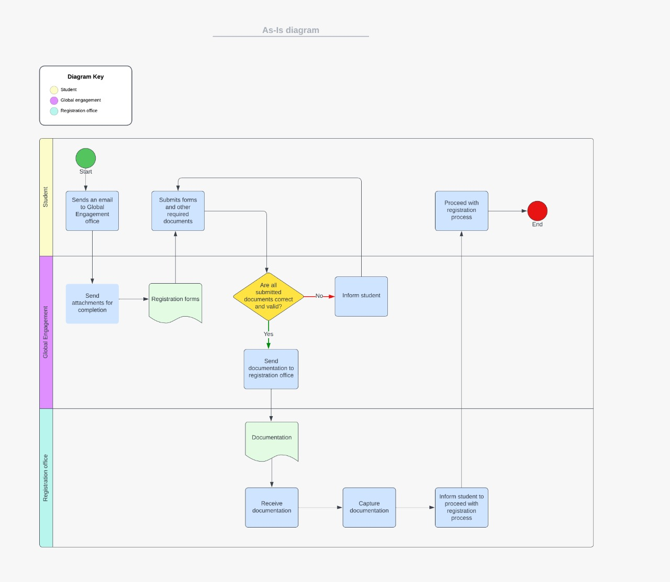

### To-Be Analysis

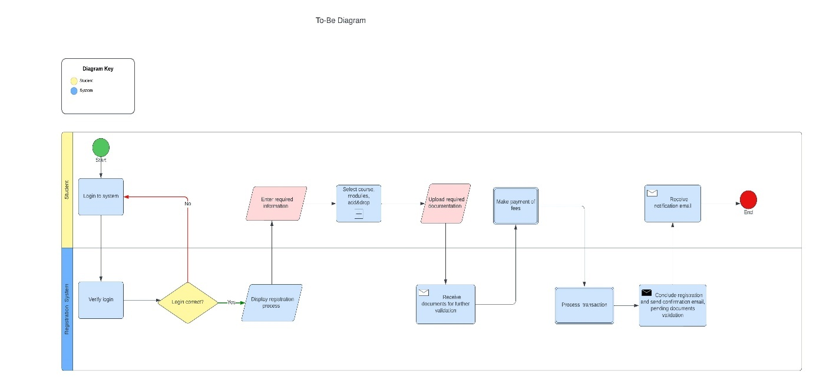

## Requirements Determinations

### Functional requirement

Functional requirements are the features that a system should offer to meet the specific needs of the end user. In other words, it specifies “What should the software do?”.

**Here are the functional requirements for the proposed system:**

1. **Student**
   1. Login: Students would need unique login credentials.
   2. Forgot password: Changes to student passwords should be possible.
   3. Student will be uploading all the required documents for registration
   4. Student will choose modules for the semester year they are enrolling for.
   5. Students will input banking details or proof of payment for transaction.
   6. Student can login and logout.
2. **Administrator**
   1. Login: Administrator would need unique login credentials.
   2. Forgot password: Changes to student administrator passwords should be possible.
   3. Administrator should be able to access all system components.
   4. A student's registration should be approved or disapproved by the administrator.
   5. Administrator can login and logout.
3. **Global Engagement Office (GEO)**
   1. Login: GEO would need unique login credentials.
   2. Forgot password: Changes to GEO passwords should be possible
   3. GEO will have access to students submitted documents.
   4. GEO approve if student is legible or ineligible to register.
   5. GEO can login and logout into the system.
4. **Input**

This will be the systems respective inputs:

* 1. Student, Administrator and Global Engagement Office login details (Username and Password)
  2. Student uploads different types of documents
  3. Student banking details

1. **Process**

This will be the systems respective process:

* 1. Storing students, administrator, and GEO login details into the database.
  2. Storing student’s profiles and details in the database.
  3. Storing student’s banking details of proof of payments.
  4. Storing required documents from the student.

1. **Output**

6.1 Display relevant student details to the GEO

Non-functional requirements

1. **Operational Requirements**

* The system is web-based, meaning users require internet connection to access it and it is accessible with any device.
* The system will read and write to the main inventory database.

1. **Performance requirements**

* The system will modify the database after each registration or change user profile, in a less than 10 seconds.

1. **Security requirements**

* The system will validate user input (Login)
* Only the administrator and GEO can access student details

The system will be developed using HTML (Hypertext Markup Language), CSS (Cascading Style Sheet), PHP and lastly MySQL database.

Software required to run the system is determined as follow:

1. Server side: Install Xampp, to create the database
2. Client side: Internet browser

The system will have a user-friendly interface making it easier for users to browse and complete their tasks.

## Use cases

### Use case diagram

##### 

##### Use case description table

##### Student

|  |  |
| --- | --- |
| **Use case** | Student registration |
| **Actor** | Student |
| **Description** | |
| Student register on the system | |
| **Successful Completion** | |
| **Actors action** | **System response** |
| 1. Student login into system 2. Student register    1. Upload documents    2. Select modules 3. Student makes payment 4. Student logout | 1. System display login page 2. System verifies login details 3. System display registration form 4. System display add/drop form for documents 5. System process transaction 6. System process registration 7. System updates database |
| **Alternative** | |
| **Actors action** | **System response** |
| 1. Student fails to login    1. Student tries to login again    2. Student resets password 2. Student logins successfully | 1. System display login page 2. System verifies login details 3. System display password reset form 4. System updates database 5. System displays registration form |
| **Precondition** | |
| Student must be an existing entity in the system | |
| **Post conditions** | |
| 1. Student awaits approval from GEO and Admin    1. If student registration is approved  * Student will enrol for the present year   1. If student registration is disapproved * Details will be communicated | |

##### Administrator

|  |  |
| --- | --- |
| **Actor** | Administrator |
| **Description** | |
| Administrator validation and verification of student registration | |
| **Successful Completion** | |
| **Actors action** | **System response** |
| 1. Administrator login 2. Administrator views student profile 3. Administrator approves student registration 4. Administrator updates student profile | 1. System display login page. 2. System verifies login details 3. System display students’ profile 4. System updates database |
| **Alternative** | |
| **Actors action** | **System response** |
| 1. Administrator login 2. Administrator views student profile 3. Administrator disapproves student registration 4. Administrator updates student profile | 1. System display login page. 2. System verifies login details 3. System display students’ profile 4. System updates database |
| **Precondition** | |
| Administrator must be a fully registered staff under North West University Mahikeng Campus | |
| **Post conditions** | |
| Administrator continue verifying and validating more students registering | |

##### GOE

|  |  |
| --- | --- |
| **Actor** | Global Engagement Office |
| **Description** | |
| Global Engagement Office authenticate student required documents for registration | |
| **Successful Completion** | |
| **Actors action** | **System response** |
| 1. GOE login 2. Access student profile 3. Verify required documents 4. Approves student registration 5. Logout | 1. System display login page. 2. System verifies login details 3. System display students’ profile 4. System displays add/drop form 5. System updates database |
| **Alternative** | |
| **Actors action** | **System response** |
| 1. GOE login 2. Access student profile 3. Verify required documents 4. Disapproves student registration 5. Logout | 1. System display login page. 2. System verifies login details 3. System display students’ profile 4. System displays add/drop form 5. System updates database |
| **Precondition** | |
| The Global Engagement must be granted permission to access student profile | |
| **Post conditions** | |
| Global Engagement Office continues validation and verification of other students | |

## Data and Process Models

### Context diagram

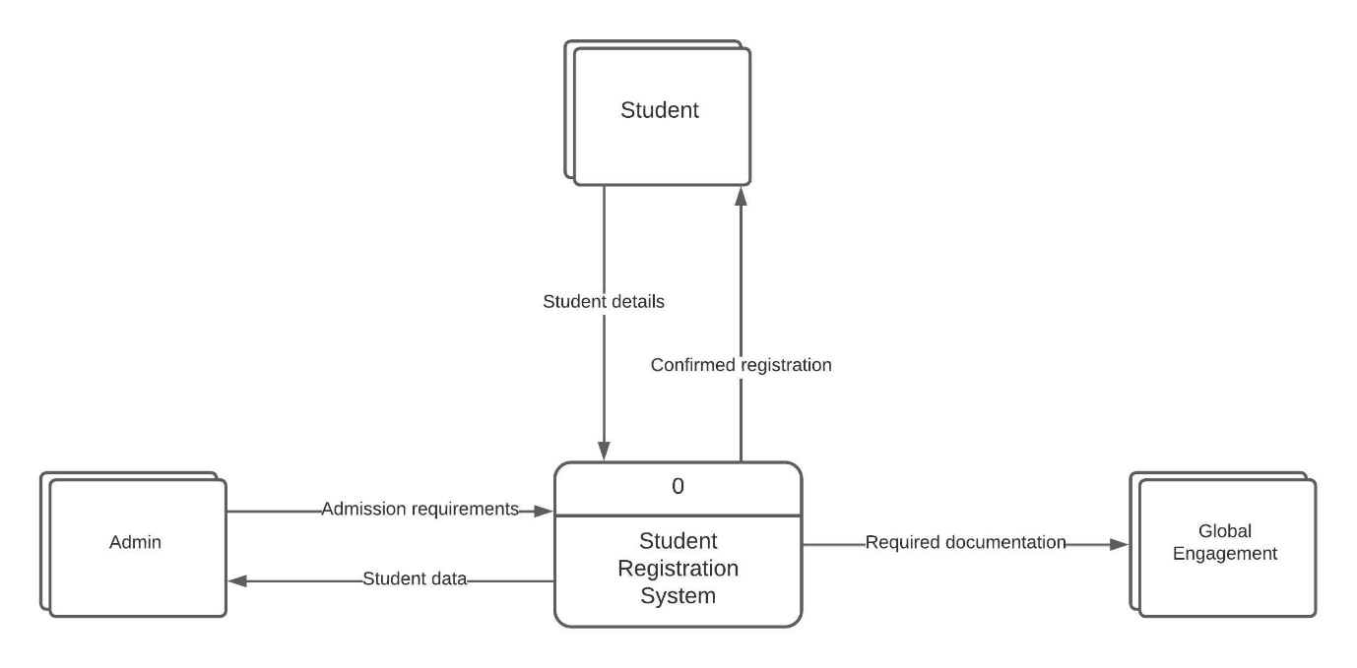

### Diagram 0

## Meetings

|  |
| --- |
| Meeting 1 horizontal line  Saturday, 03.09.2022 Attendees David Nwachukwu, Project Manager  Vusimozi Solani, Systems Analyst AgendaAnalysing the business case  * Evaluating the systems request * Preliminary investigation followed by a * Feasibility study  Evaluating the systems request  1. System review committee 2. Setting priorities  Notes  * David discussed the system development methods suitable for this project * Vusi suggested that we use the system development life cycle  Action Items  1. Conduct a thorough preliminary investigation of the proposed system  Next Meeting Agenda Items Present a preliminary investigation report for further analysis. |

|  |
| --- |
| Meeting 2 horizontal line  Tuesday, 13.09.2022 Attendees David Nwachukwu, Project Manager  Vusimozi Solani, Systems Analyst AgendaProject planning  * Set goals * Prioritize tasks * Scheduling * Understanding project scope  Developing a project plan  1. Work breakdown structure 2. Gantt chart 3. Reassess  Notes  * A comprehensive project plan will be constructed subsequently.  Action Items  1. Start project planning and management  Next Meeting Agenda Items Requirements determinations and process models. |

|  |
| --- |
| Meeting 3 horizontal line  Saturday, 20.09.2022 Attendees David Nwachukwu, Project Leader  Vusimuzi Solani, Assistant Project Leader AgendaRequirements determinations and documentation  * Defining systems requirements * Determine user requirements * Functional and non-functional requirements * Prepare documentation  Developing use cases process models  1. Identify proper diagramming tools 2. Evaluate process models  Notes  * No further notes  Action Items  1. Provide a detailed phase one documentation 2. Compile and present documentation  Next Meeting Agenda Items Commence phase two and web development. |

## PHASE TWO

## 2.1. Design Strategy.

The top down strategy will be implemented for this system. High-level modules will be identified, and it will be divided into submodules until it cannot be furthered subdivided.

**High-level module**

The high-level module is the proposed system on its own, as it will perform various tasks, i.e.:

1. Login
2. Register
3. Make Payment
4. Logout

**Modules**

The system consists of the following modules:

1. **Login Page**

The login form will enable user to enter their login credentials i.e.: student number and password.

If the credentials are valid the system will move to the next page. And if the credentials are invalid meaning the password or student number doesn’t match those stored in the database, the user will be denied access into the system.

The system will then provide user the following options:

* Try again (Input correct student number / password)
* Forgot password (For the user to reset and create a new password)

1. **Profile**

The profile page will display user their personal details and all the necessary details.

1. **The Registration Page**

The registration page will allow user to select the modules to enrol for.

1. **Upload documents Page**

The upload documents page will enable user to upload all the required documents, which will be sent to the database.

1. **Logout Page**

This page will enable user to logout.

The structured design methodology will be utilized to identify the inputs and outputs of developing a system by using data flow, with the aim of minimizing complexity and to increase modularity. Additional it describes how a system function.

## 2.2. Design Architecture.

The proposed system utilises an online processing method i.e., transactions are handled when and where they occur, and output is provided directly to users.

The design architecture employed in this system is a distributed computing strategy called client/server architecture:

* The **client** of a typical client/server system is responsible for handling the entire user interface, including data entry, querying, and presentation logic.
* The **server** is responsible for storing data, provide data access and database management.
* The **application logic** is divided between the client and the server.

In this client/server interaction, the client (laptop, pc, or mobile device) submits a request for information from the server (web server, database server), which performs the operation and replies to the client.

*Figure 1. Client/server design and interaction*

## 2.1.1. Three-tier Architecture

A **three-tier web-based client/server architecture** is utilised in this system. The client computer is responsible for the presentation logic, an application server is responsible for application logic and a separate database server is responsible for data storage and access logic. In most cases, the user interface, functional process logic (business rules), data storage, and data access are all designed and maintained on as separate modules on different platforms.

* Client (pc) – presentation logic
* Application server (pc) – application logic
* Database server (pc, server farm, or mainframe) – data access logic, data storage.

*Figure 2. Three-tier client/server architecture.*

## 2.1.1 The Client

The client mainly handles the presentation logic. The most basic client can be a PC or a mobile device running on windows, android, iOS or MacOS respectively. It must have a web browser in order to access the website via the Internet. The client is concerned with the presentation tier which is the user interface and communication layer of the application where the end user interacts with the application. Basically, it displays and collects information from the user. For example, this top-level tier can run on a web browser (Chrome or Firefox) as a desktop application, or as a graphical user interface (GUI). HTML, CSS, and JavaScript are commonly used to develop web presentation tiers.

## 2.1.2 The Application Logic

The application logic, also known as the business logic layer or middle layer. It processes information/request from the client in detail using business logic – a specific set of business rules. Likewise, data can be added, deleted, or modified by the application tier. The application tier in this system is developed using PHP, which communicates with the database server using application programming interface (API) calls.

## 2.1.3 Database Server

This is where information processed by the application is managed and stored. This can be a relational database management system (RDBMS) such as MySQL, Oracle, MariaDB or Microsoft SQL Server. The proposed system’s database is implemented using XAMPP Server 8.1.10. XAMPP mainly consists of Apache HTTP Server, MariaDB database, and script interpreters written in PHP. It is easy to switch from a local test server to a live server since most web servers use the same components as XAMPP. Users are provided with the ability to manage and administer the database easily. Employing XAMPP Server as the RDBMS of the system allows the user to create server-side cursors to manipulate table records programmatically.



Ultimately, a three-tier architecture provides better performance, scalability, flexibility, and availability.

## 2.2. Interface Report

### Home Page

This is the landing page for the student.

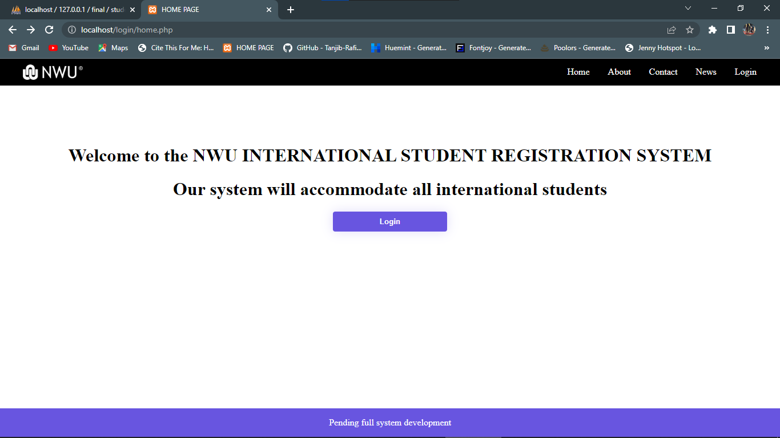

Figure 1: The user will proceed by clicking the login button.

### Login Page

This is the login page

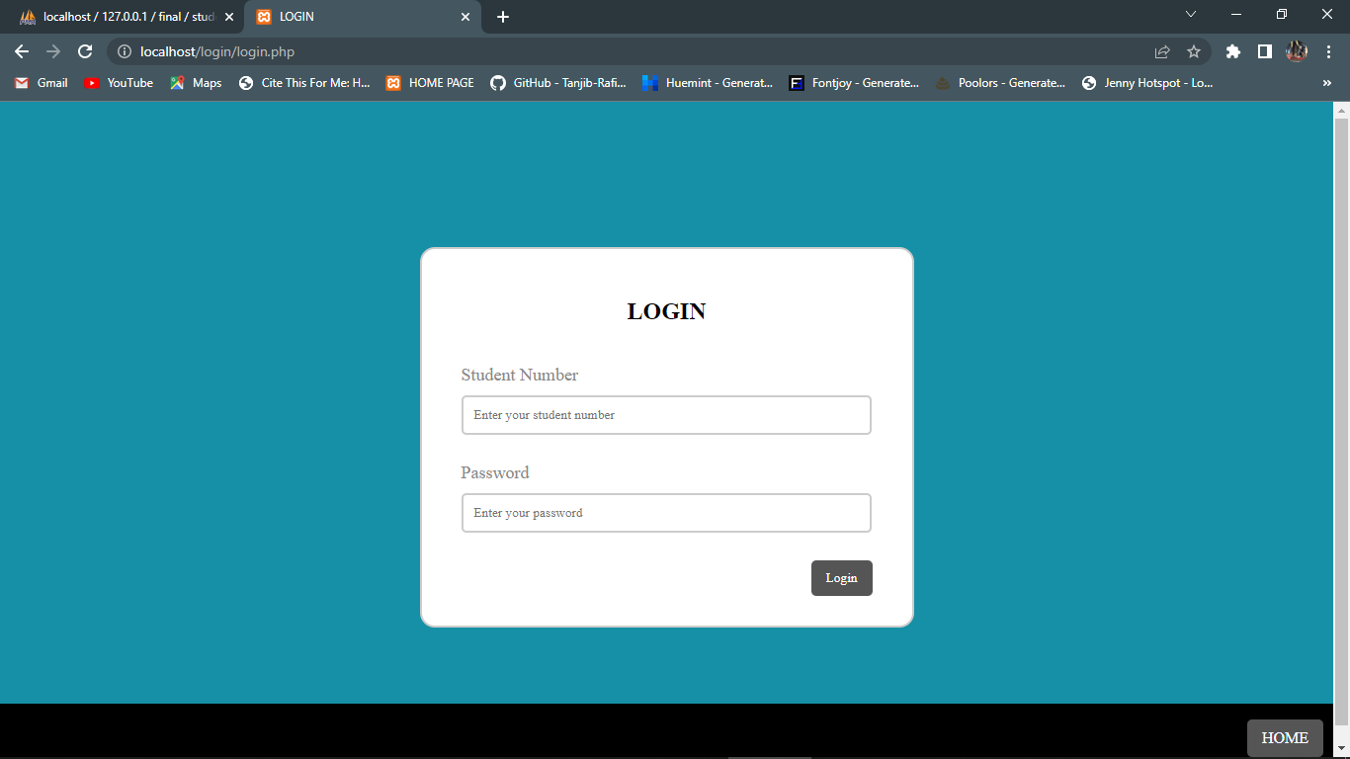

Figure 2: The user will input their login credentials (Student number and password).

If user inputs the wrong credentials



Figure 3: User must input correct credentials to proceed.

### Profile Page

The details used for logged in student



Figure 4: The student number is (33414241) and the password is (Vusi2001) #Note(Credentials are not real)

This will be the landing page when the user has successfully logged in, where all the necessary

Information will be displayed.

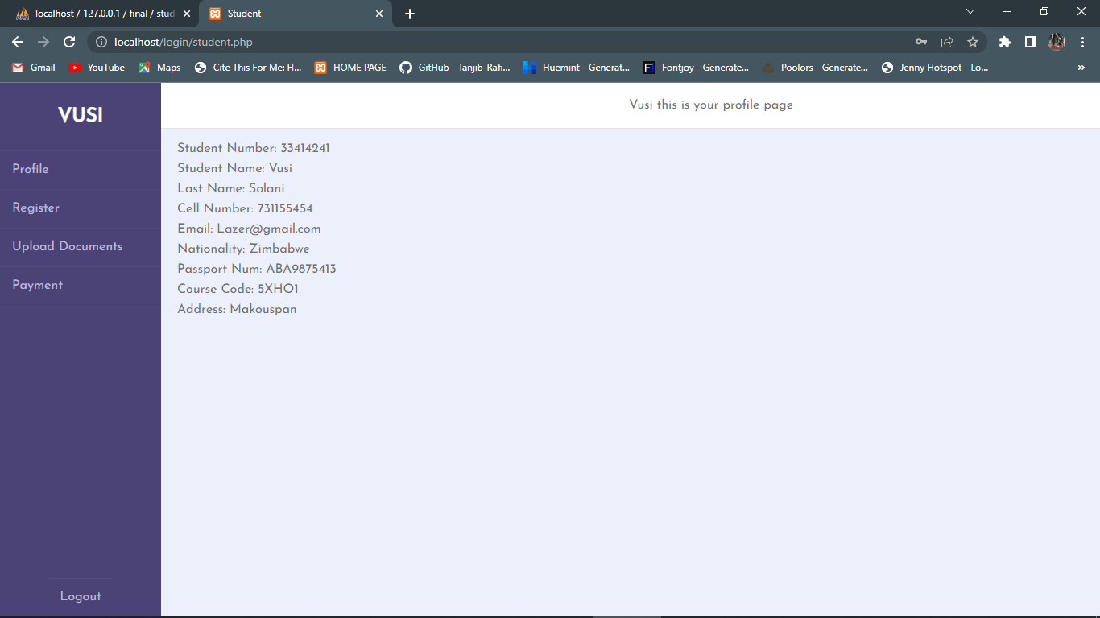

Figure 5: The student name is displayed at the top left corner.

### Registration Page

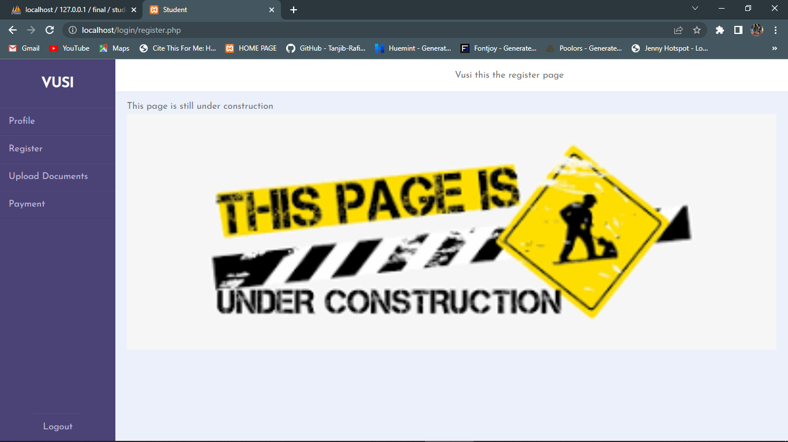

Figure 6: As shown here the page is still under construction. Its purpose is to allow students to select the modules/ course/ year they going to enrol for.

The remaining pages (Upload document and Payment page) are under construction. But the user is

able to click logout and they will be landed to the login page again.

## 2.3. Physical Process Model

The DFD’s

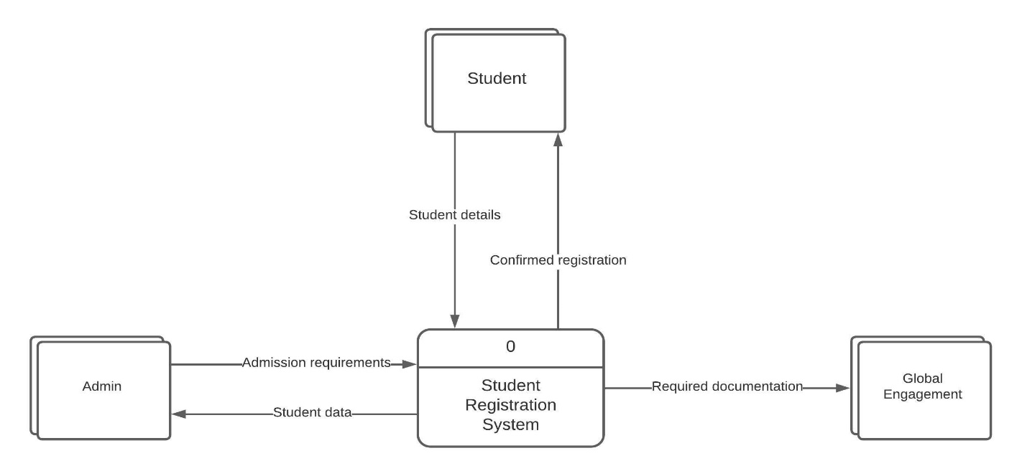

Figure 7: Context 0

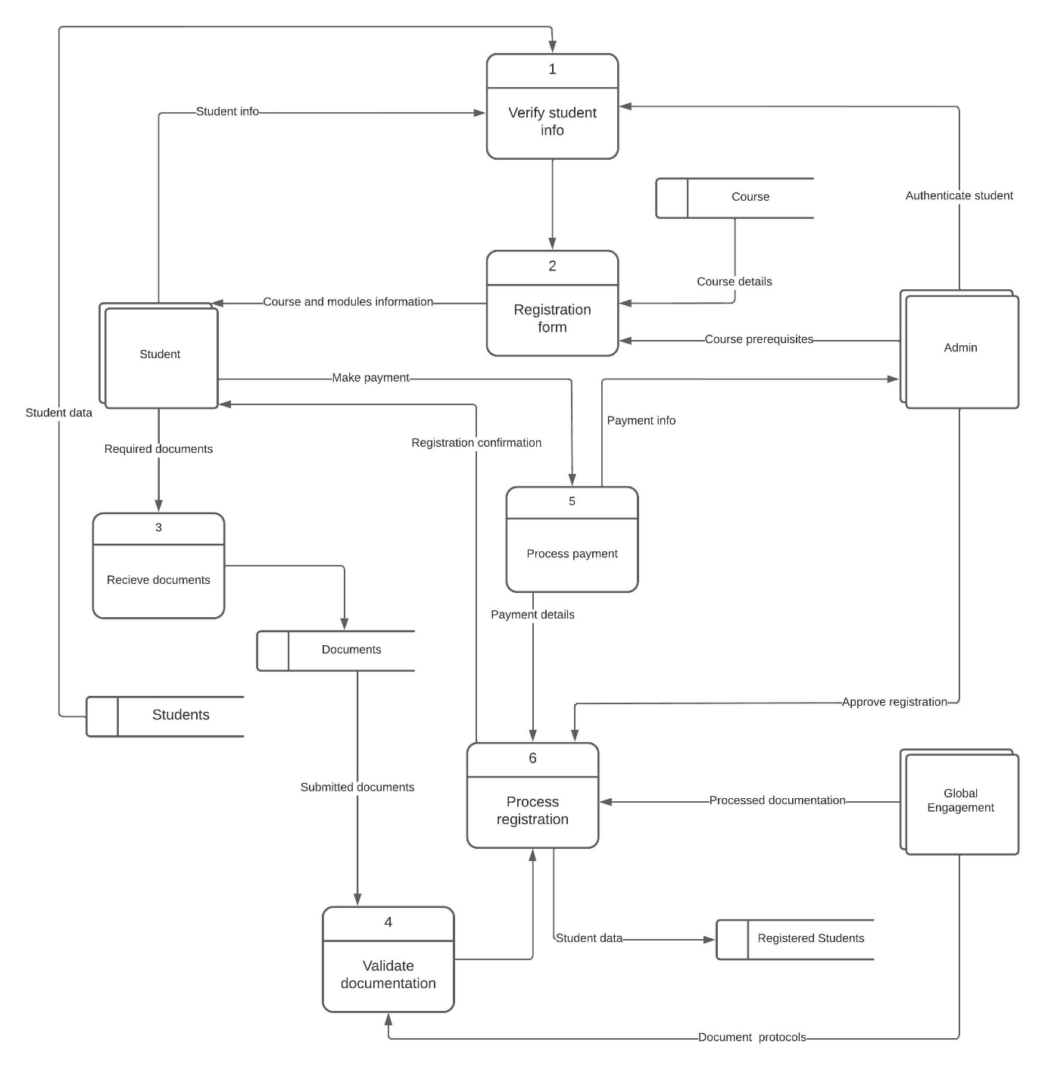

Figure 8: Diagram 0

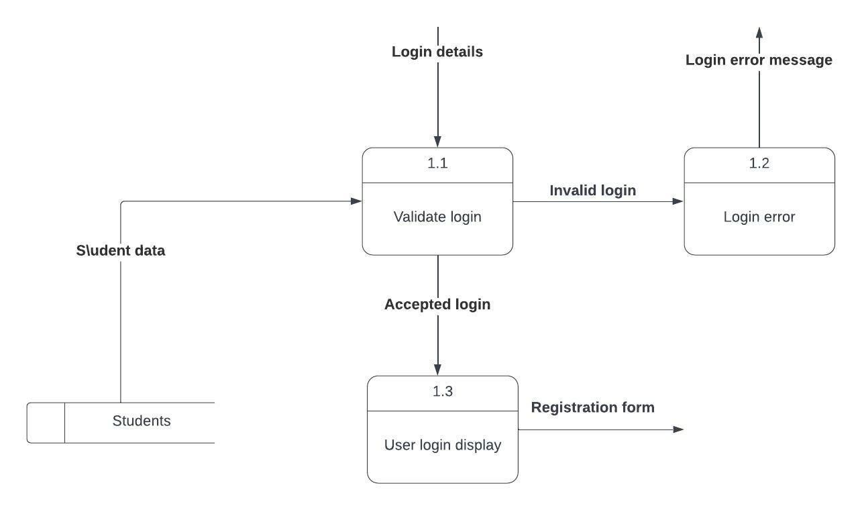

Figure 9: Diagram 1

Structured chart:



## Entity Relational Diagram

**Business rules**

* A student can take only one course. A course can be taken by one or many students
* A student can upload one to many documents, and documents can be uploaded by one student
* One student can make one registration, and registration can be made by one to many students
* Payment can be made by one or many students, a student can only make one payment
* A course can contain many modules, a module can refer to one or many courses
* A module can be taught by one instructor, an instructor can teach one to many module
* Course can fall under only one-faculty, a faculty can have many courses

**Entities**

1. Students
2. Course
3. Admin
4. Payment
5. Documents
6. Modules
7. Instructor

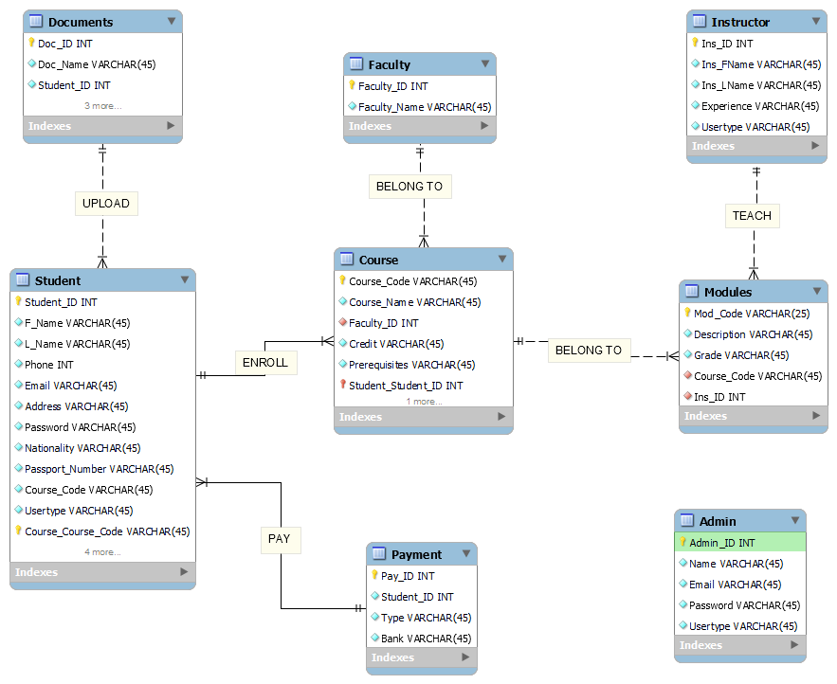

## Reference list – Harvard referencing style

AltexSoft. 2022. *Functional and Nonfunctional Requirements: Specification and Types*. [online] Available at: <https://www.altexsoft.com/blog/business/functional-and-non-functional-requirements-specification-and-types/#:~:text=Functional%20requirements%20are%20product%20features,system%20behavior%20under%20specific%20conditions.> [Accessed 13 September 2022].

Cousins, M., 2021. *As Is -To Be: The Essential Business Model for Process Improvement*. [online] Blog.triaster.co.uk. Available at: <https://blog.triaster.co.uk/blog/as-is-to-be-essential-business-model-process-improvement#:~:text=Effective%20Continuous%20Improvement-,How%20the%20As%20Is%20%2D%20To%20Be%20Model%20Works,breakdowns%20and%20areas%20of%20risk> [Accessed 21 September 2022].

Csd.uoc.gr. 2022. [online] Available at: <https://www.csd.uoc.gr/~hy351/2005/downloads/assisting_lectures/HY351_F2.pdf> [Accessed 12 September 2022].

FitzGerald, J., Dennis, A. and Durcikova, A. (2021) *Business Data Communications and networking*. Hoboken, NJ: Wiley

Gantt.com. 2022. *Gantt.com*. [online] Available at: <https://www.gantt.com> [Accessed 18 September 2022].

IBM Cloud Education (2020) *What is three-tier architecture*, *IBM*. Available at: https://www.ibm.com/cloud/learn/three-tier-architecture (Accessed: October 12, 2022).

Lucidchart.com. 2022. *The Basics of Documenting and Analyzing Your As-Is Process | Lucidchart Blog*. [online] Available at: <https://www.lucidchart.com/blog/as-is-process-analysis#:~:text=What%20is%20as%2Dis%20process,within%20a%20department%20or%20team>. [Accessed 19 September 2022].

ProjectManager. 2022. *Ultimate Guide to PERT*. [online] Available at: <https://www.projectmanager.com/guides/pert-chart> [Accessed 15 September 2022].

ProjectManager. n.d. *Work Breakdown Structure (WBS): The Ultimate Guide (with Examples)*. [online] Available at: <https://www.projectmanager.com/guides/work-breakdown-structure> [Accessed 17 September 2022].

Rosenblatt, H.J. (2014) *Systems analysis and design*. South Melbourne: Course Technology Cengage Learning.

Shelly, G. and Rosenblatt, H., 2017. *Systems analysis and design*. 11th ed. Boston, MA: Cengage Learning.

Wrike.com. 2022. *Business Requirements Document (BRD) Guide & Template | Wrike*. [online] Available at: <https://www.wrike.com/blog/how-write-business-requirements-document/#Business-requirements-document-example-and-template> [Accessed 12 September 2022].

*W3Schools free online web tutorials* (no date) *W3Schools Online Web Tutorials*. Available at: https://www.w3schools.com/default.asp (Accessed: October 2, 2022).

## Website Screenshots

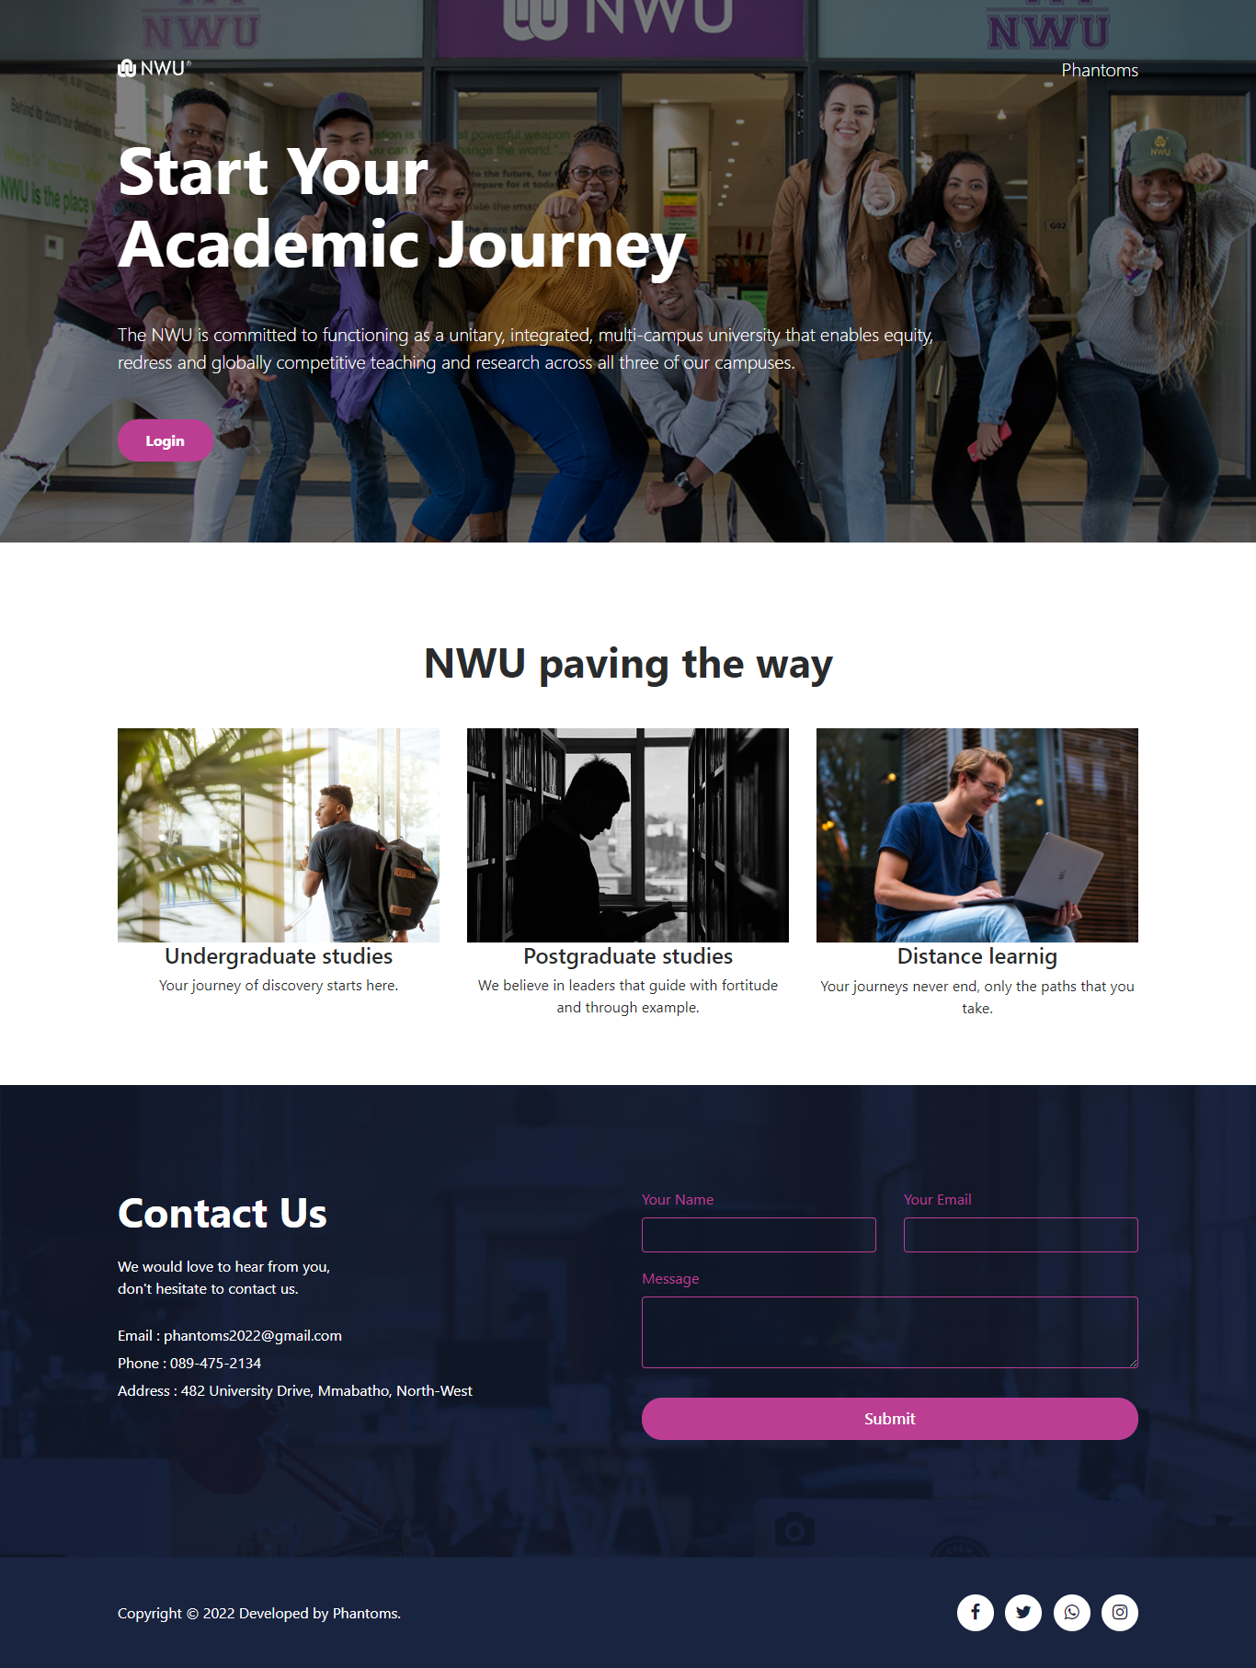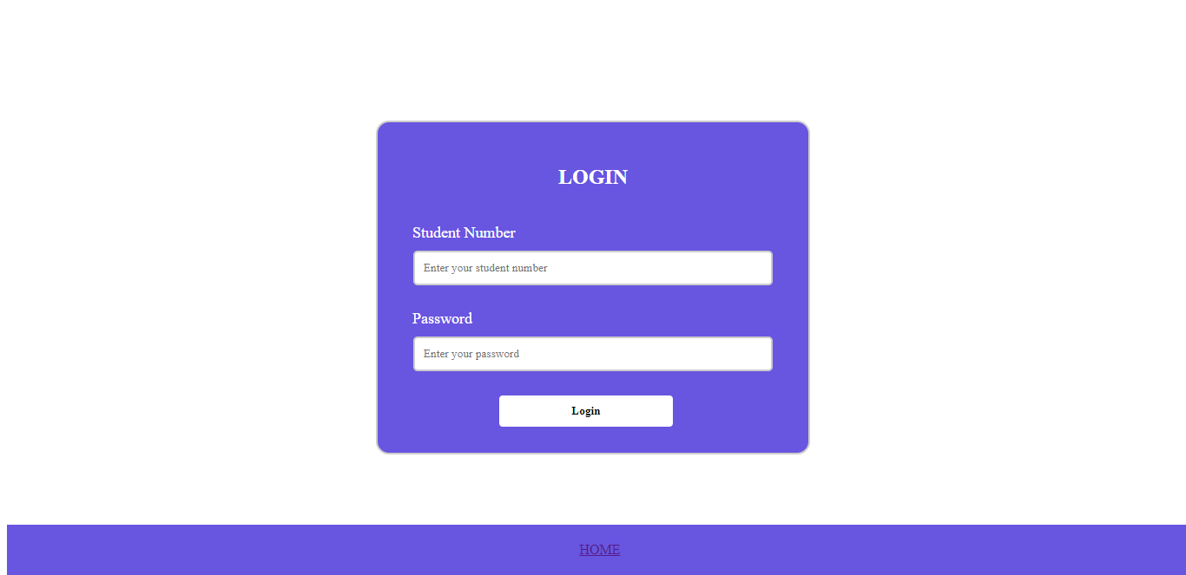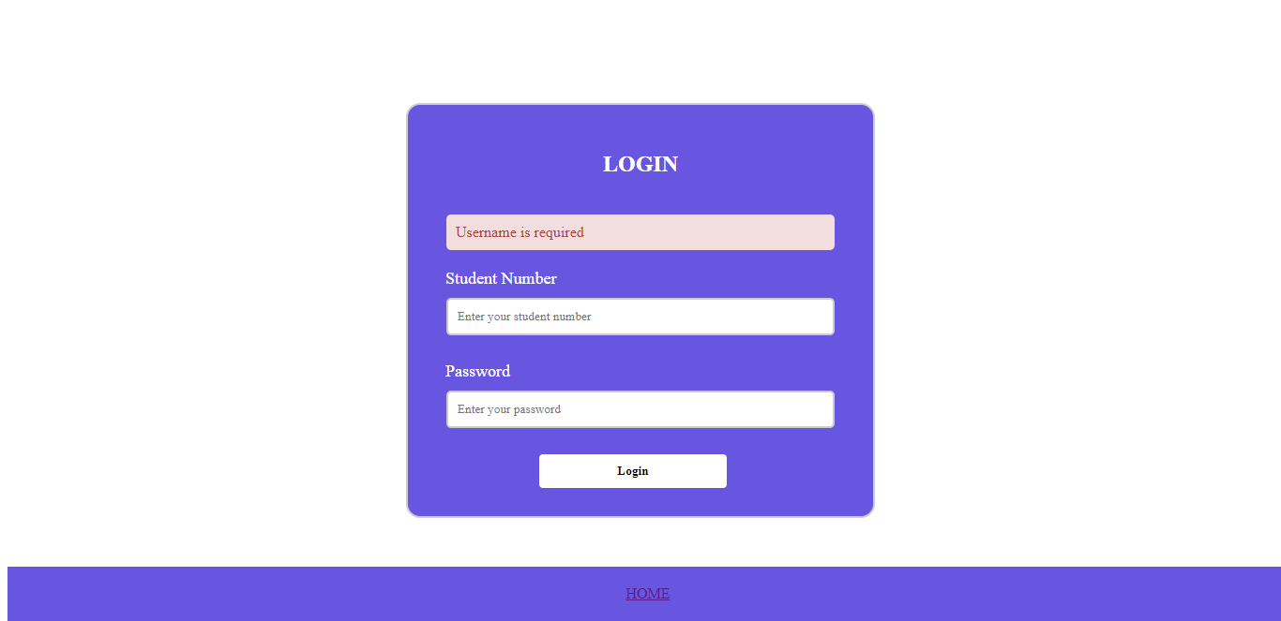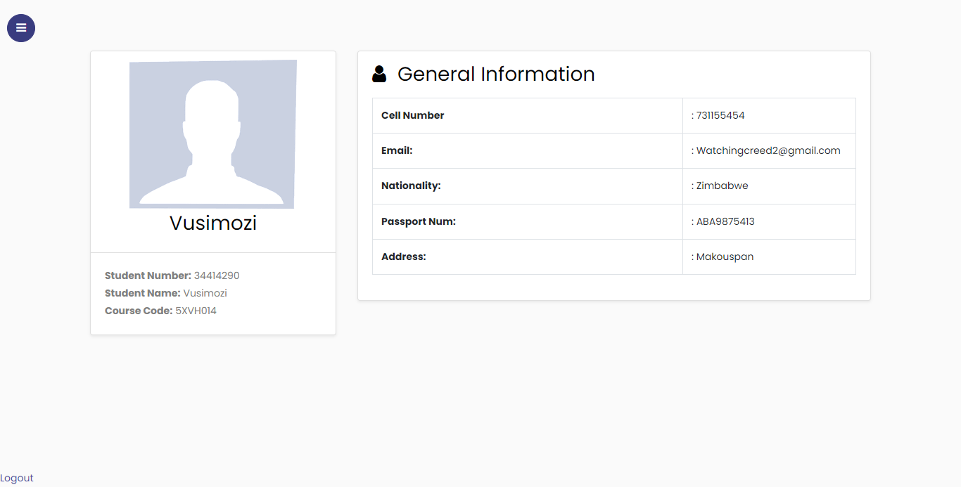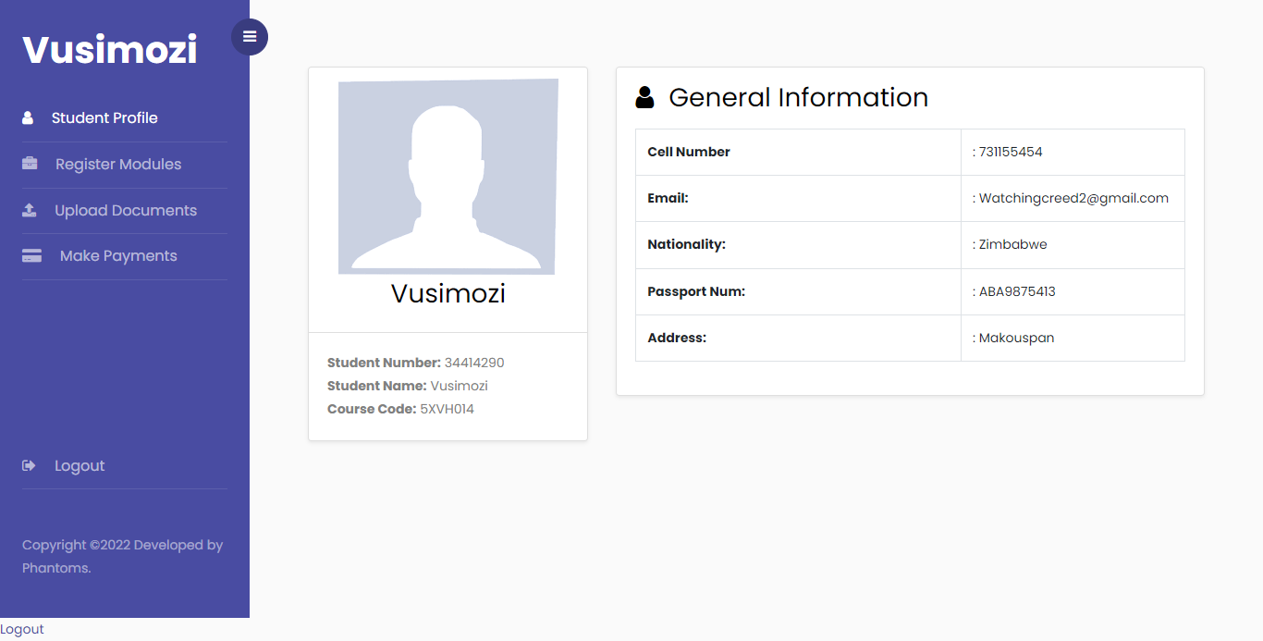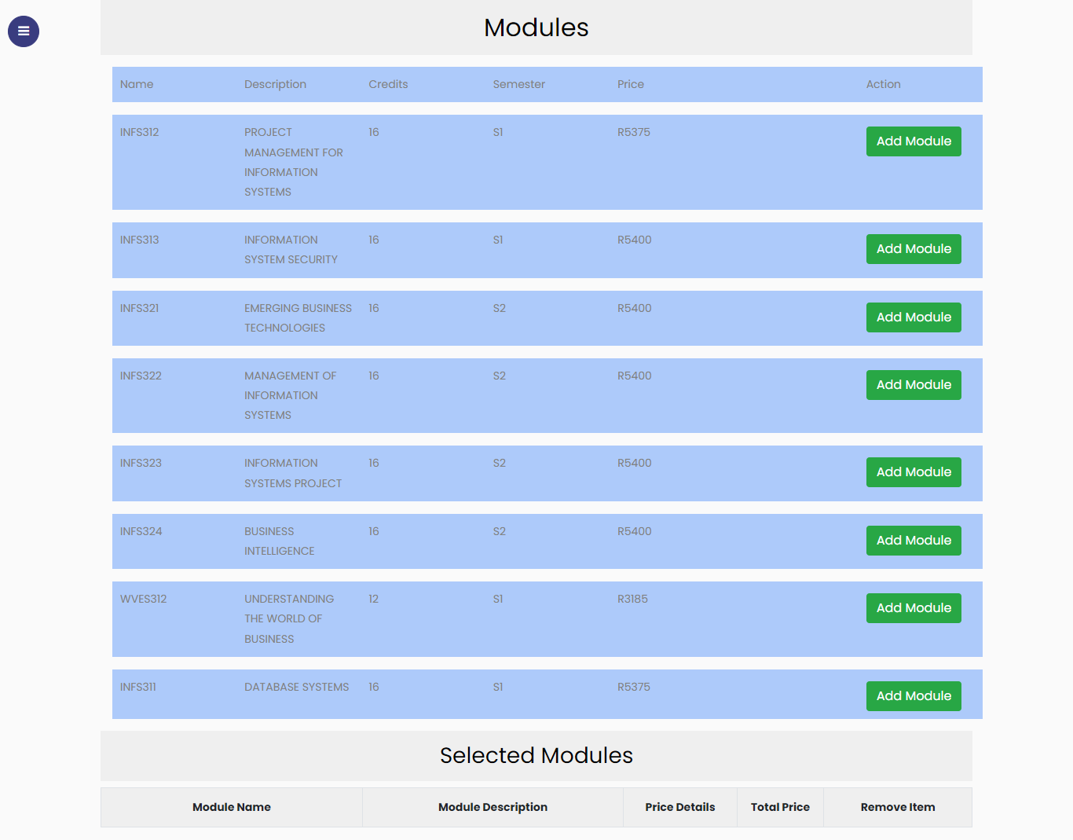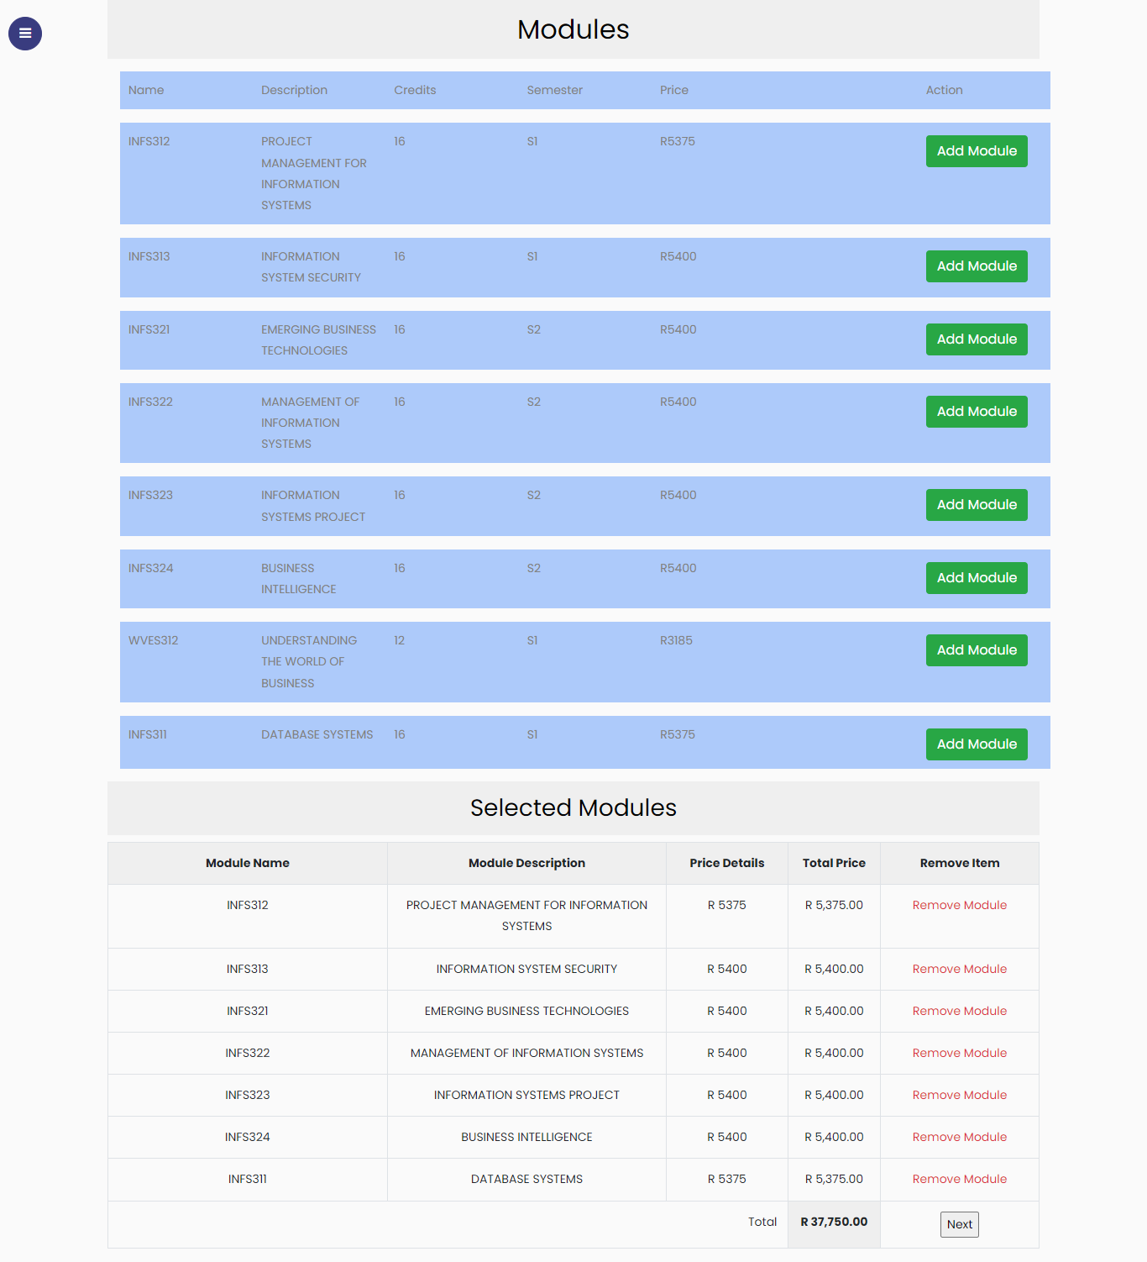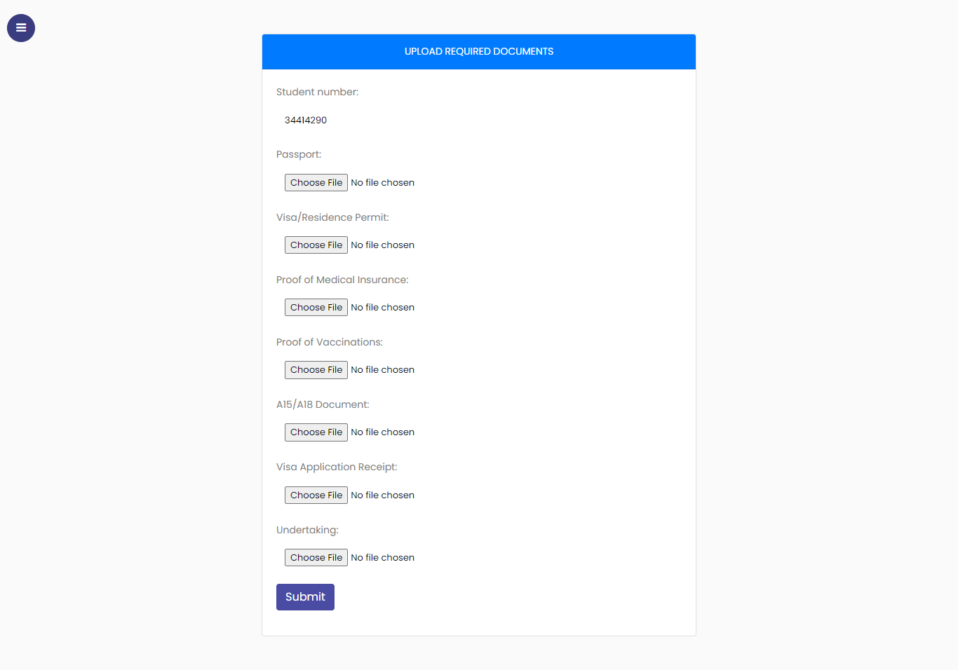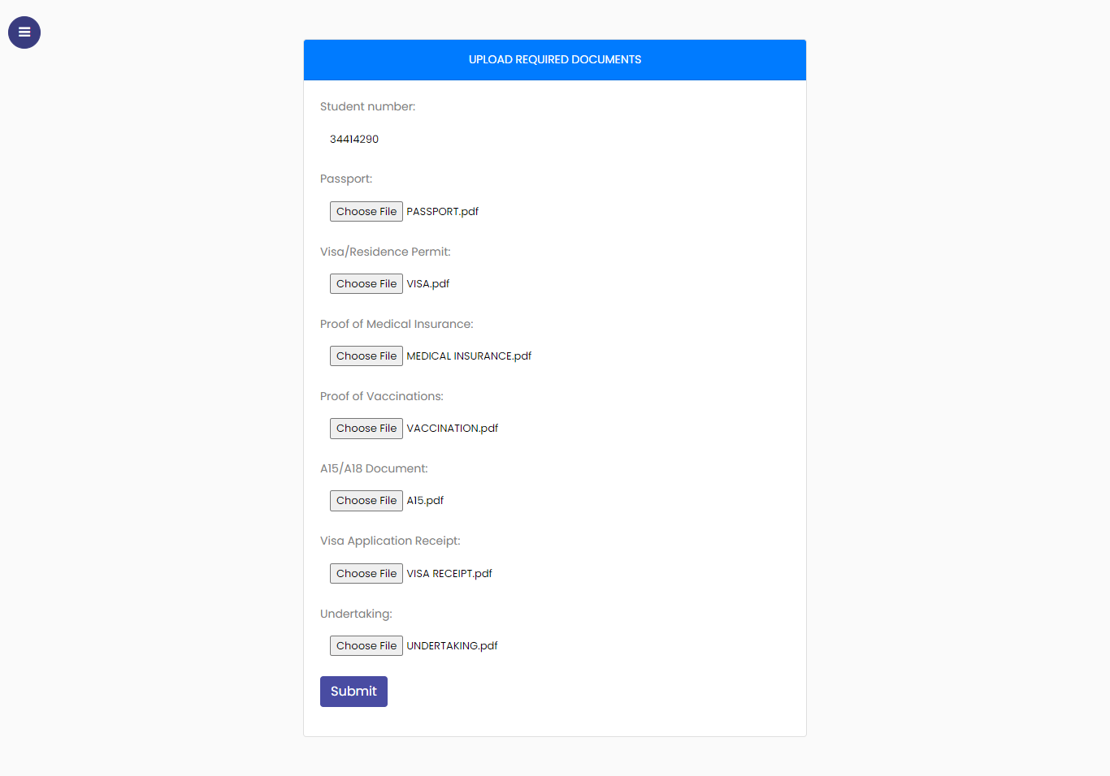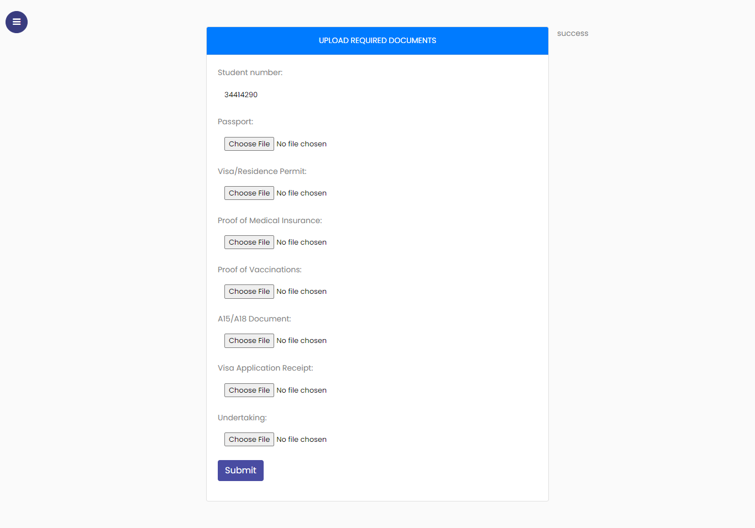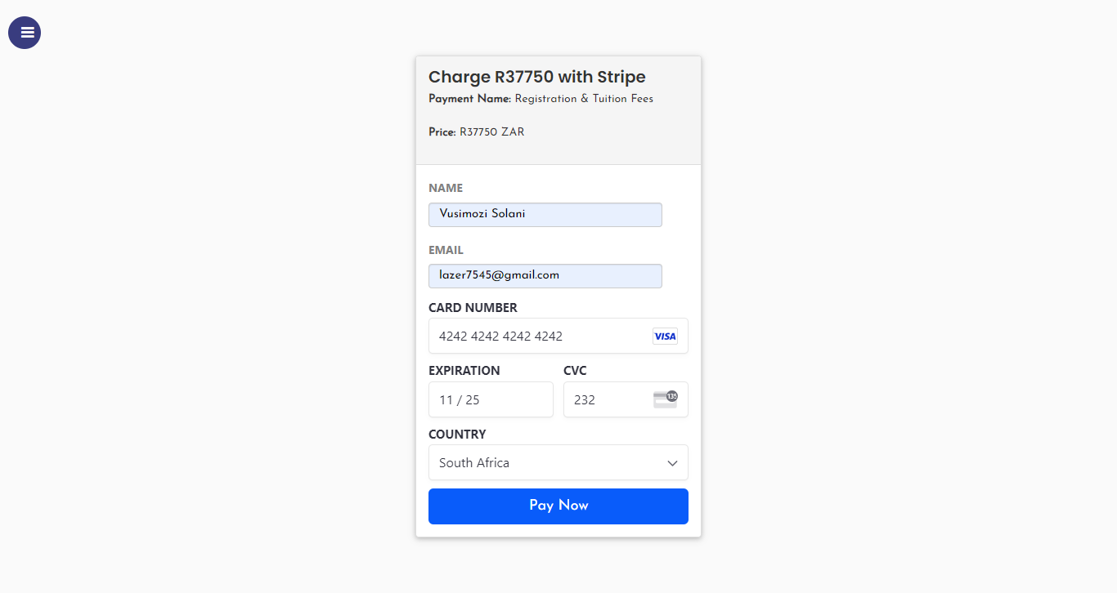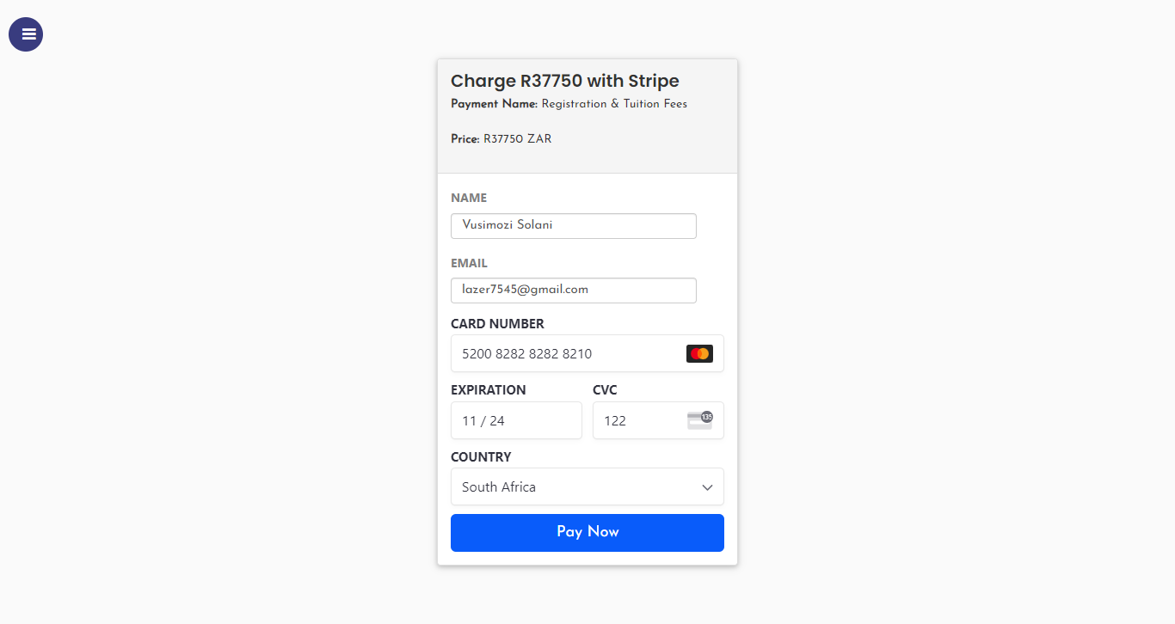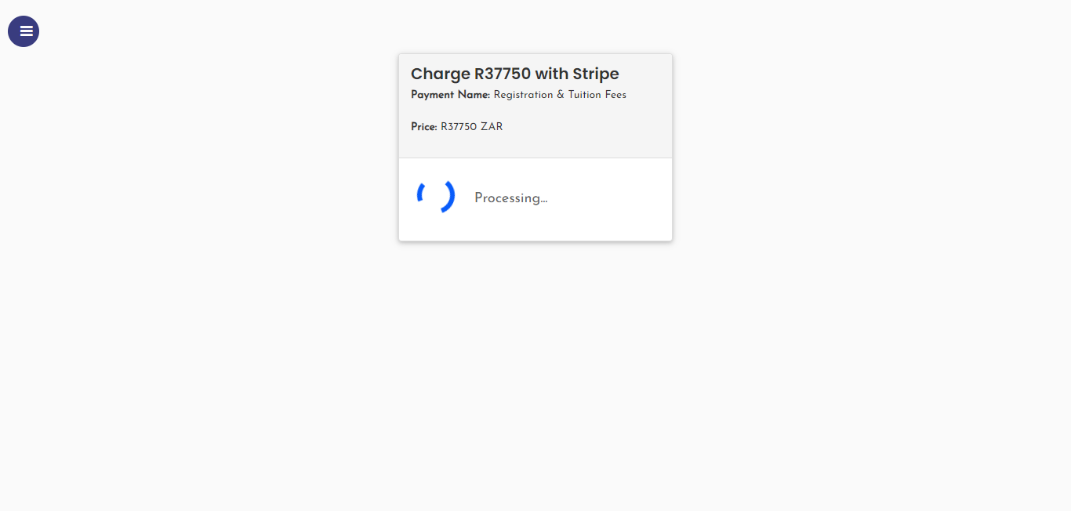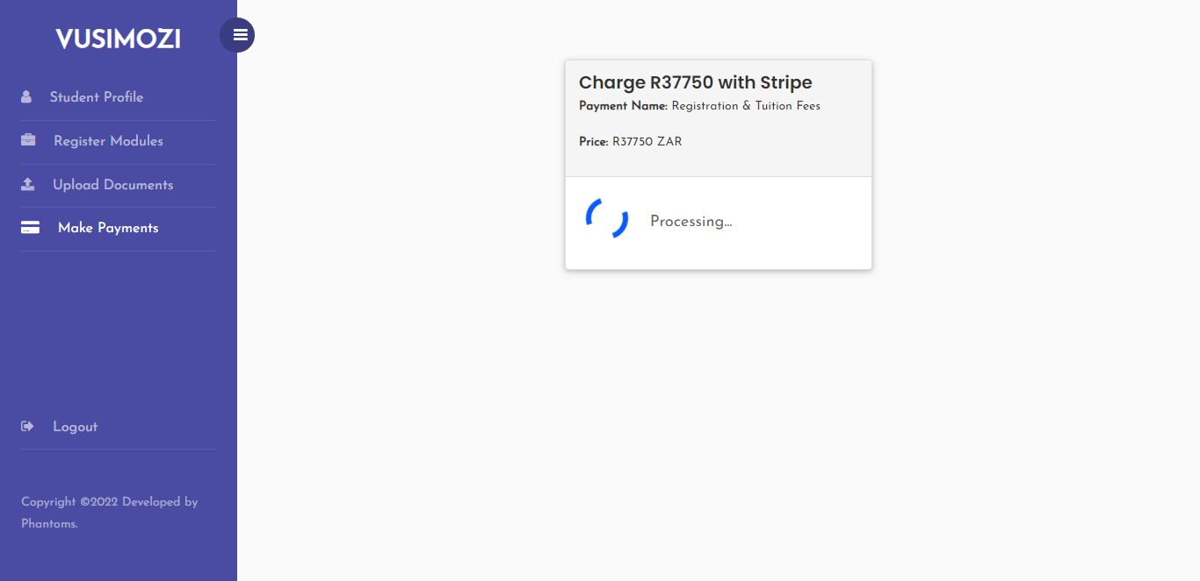

## How To Run File

### **Student features**

* Secure Login
* Update Password
* View Profile
* Register
* Select modules
* Upload documents
* Make payment
* Logout

## **How to Run**

**Requirements**

* **Download**and **Install**any**local web server** such as **XAMPP.**
* **Extract**the provided source code **zip** file.

**Installation/Setup**

1. **Open**your **XAMPP’s Control Panel** and start the **Apache** and **MySQL**.
2. **Extract**the **source code zip file**.
3. If you are using **XAMPP**, **copy**the extracted source code folder and **paste**it into the**XAMPP's "htdocs" directory**.
4. **Browse**the **PHPMyAdmin**in a **browser**. i.e. **http://localhost/phpmyadmin**
5. **Create**a **new database** naming **final**.
6. **Import**the provided **SQL**file.
7. **Browse**the **Online Student Registration System – International Students** in a **browser**.

## **Login Information**

**Username:** 34414290  
**Password:** Creed@12